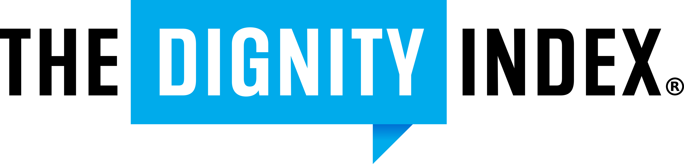

SAMPLE ONE- Formal

Resolution to Promote Dignified Discourse and Productive Communication

WHEREAS, this/these [individuals, organizations, and or governing bodies] affirm dignity as a fundamental principle of easing division, constructive engagement in civic, professional, and community spaces; and
WHEREAS, contemptuous language causes division, and evokes polarization; and
WHEREAS, the Dignity Index provides an evidence-based framework to assess and promote speech that upholds respect, constructive dialogue, and unity; and
WHEREAS, when we use contempt, its hard to see, when we start to see it, its hard to use it and the Dignity Index helps us see it

THEREFORE, BE IT RESOLVED THAT:
Commitment to Dignity: The undersigned [individuals, organizations, and or governing bodies] will strive to uphold the principles of dignity in forms of communication, including public statements, discussions, workplace interactions, and digital engagement.
Use of the Dignity Index: In adopting this resolution this body and its people can utilize the Dignity Index as a framework to guide, assess, and improve discourse within their respective domains.
Non-bias Application: The principles of dignity shall be applied universally, without bias, discrimination, or favoritism, ensuring fair dialogue across all sectors.
BE IT FURTHER RESOLVED THAT: those participating in proceedings and interactions with this body, its people, and other participants will be held to similar standards of discourse and will be encouraged to conduct themselves in a way that strives to reflect these same principles.

ADOPTED THIS [DATE] BY [ORGANIZATION/GOVERNING BODY/COMMUNITY].
SIGNED:
Effective Date: This resolution shall take effect immediately upon its adoption.

