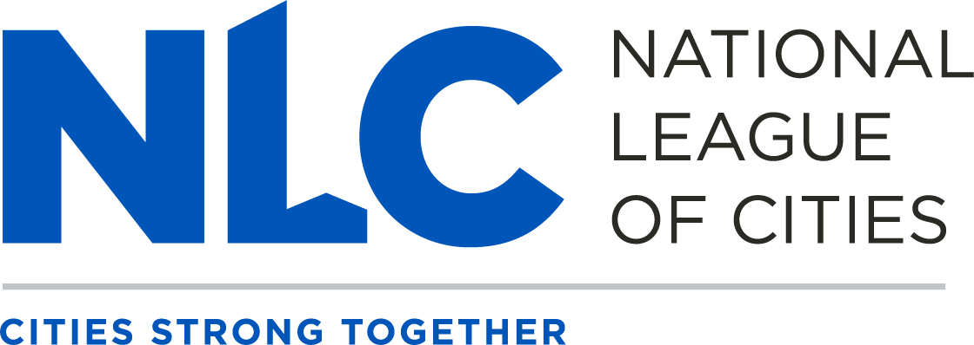
2023 Council on Youth, Education, and Families Roster

Co-Chairs
The Honorable Van R. Johnson, II, Mayor, City of Savannah, GA
The Honorable Gloria Solorio, Councilmember, City of Avondale, AZ

Vice Chairs
The Honorable Beckie Hayes, Councilmember, City of Forest Hill, TX
The Honorable Vanessa Fuentes, Councilmember, City of Austin, TX

NLC Board of Directors Liaison
The Honorable Adam McGough, Councilmember, City of Dallas, TX

Members
Mr. Anthony Amado, Youth Representative, City of Casa Grande, AZ
The Honorable Kathryn Abbott, Vice Mayor, Village of Pinecrest, FL
Ms. Alexis Apodaca Government Relations Coordinator, City of Chandler, AZ
The Honorable Larry Avery, Councilmember, City of Gadsden, AL
The Honorable Nathaniel Booker, Mayor, Village of Maywood, IL
The Honorable Phil Brock, Councilmember, City of Santa Monica, CA
The Honorable Tyrone Brown, Councilmember, Town of Dumfries, VA
The Honorable Angelyne Butler, Mayor, City of Forest Park, GA
The Honorable Stephen Cain, Councilmember, Town of Batesburg-Leesville, SC
The Honorable Chris Callender, Councilmember, Village of Oakwood (Cuyahoga County), OH
The Honorable Lajan Cephas, Commission President, City of Cambridge, MD
The Honorable Sputty Cephas, Commissioner, City of Cambridge, MD
The Honorable Wilmot Collins, Mayor, City of Helena, MT
The Honorable Demetrus Coonrod, Councilmember, City of Chattanooga, TN
Ms. Andrea Mercado Cruz, Youth Representative, City of Dallas, TX
The Honorable Terese Cummings, Councilmember, City of East Point, GA
Ms. Margaret Desjarlais, Community Development Program Manager, City of Tuscaloosa, AL
Ms. Sofia Dominquez-Trejo, Youth Representative, City of Austin, TX

Page 2 – Council on Youth, Education, and Families

The Honorable Deborah Figgs-Sanders, Councilmember, City of St. Petersburg, FL
The Honorable Eddie Flores, Councilmember, City of South San Francisco , CA
The Honorable Chemberly Harris, Councilmember, Town of Normal, IL
The Honorable Kathy Henson, Councilmember, City of Thornton, CO
The Honorable John Hines, Councilmember, City of Tacoma, WA
The Honorable Chip Johnson, Mayor, City of Hernando, MS
The Honorable Marche Johnson, Councilmember, City of Montgomery, AL
The Honorable Scott Jones, Councilmember, City of Mobile, AL
The Honorable Vanessa Joseph, City Clerk, City of North Miami, FL
The Honorable Kate Kennedy, Councilmember, City of College Park, MD
The Honorable NanDrycka King Albert, Councilmember, City of Midway, FL
The Honorable Rosannette Kirby, Councilmember, City of Lovejoy, GA
The Honorable Shyleen Lopez, Assistant Director Early Learning, City of Hartford, CT
Ms. Ramie Mack, Youth Representative, City of Fayetteville, NC
The Honorable Veronica Malone, Vice Mayor, City of Avondale, AZ
The Honorable Alberta McCrory Mayor, Town of Hobson City, AL
The Honorable LaMonica McIver, Council President, City of Newark, NJ
The Honorable Dixie Minatra, Councilmember, City of Gadsden, AL
The Honorable Stephanie Moon Reynolds, Councilmember, City of Roanoke, VA
Ms. Stefanie Munsterman, Executive Director, Cedar Rapids Civil Rights Commission, IA
The Honorable Scott Nicewarner, City Administrator, City of Hagerstown, MD
The Honorable John Noak, Mayor, Village of Romeoville, IL
The Honorable Todd Nock, Mayor-Elect, City of Pocomoke City, MD
Ms. Emily Norris, Youth Engagement Coordinator, City of Knoxville, TN
The Honorable Shirley Peel, Councilmember, City of Fort Collins, CO
The Honorable Susan Persis, City Commissioner, City of Ormond Beach, FL
The Honorable Silke Pope, Councilmember, City of Greenbelt, MD
Ms. Kelbrey Porter, Grants Department Director, City of Montgomery, AL
The Honorable Timothy Ragland, Mayor, City of Talladega, AL
The Honorable Nicole Raphiel, Councilmember, City of DeSoto, TX
Page 3 – Council on Youth, Education, and Families

The Honorable Kenny D. Ruffin, Councilmember, City of Riverdale, GA
The Honorable Melissa Robinson, Councilmember, City of Kansas City, MO
Ms. Sophia Rome Management Analyst, Advanced Planning & Project Implementation Division, City of Salinas, CA
The Honorable Julie Spilsbury, Councilmember, City of Mesa, AZ
The Honorable Jennifer Swezey, Assistant City Manager, City of Muskogee, OK
The Honorable Matt Turner, Alderman, City of Harrisonville, MO
Ms. Heaven Vega, Youth Representative, City of Rochester, NY

The Honorable Reddex Washington, Councilman, City of Alexandria, LA
The Honorable Glenn Williams, Councilmember, City of Center Point, AL

As of April 18, 2023

