Youth Excel Fellows – Bios
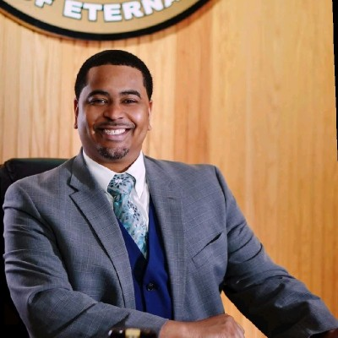
Nathaniel George Booker
Mayor
Village of Maywood, IL
The Honorable Nathaniel George Booker was sworn in as Village President(Mayor)for the Village of Maywood on May 18, 2021. Prior to being elected as Village President, Mayor Booker served as Village Trustee from 2019 until 2021. As an elected official, he serves on the National League of Cities (NLC) Board of Directors. With NLC Mayor Booker is a member of Youth, Education, and Families Council, First Tier Suburbs, along with Federal Advocacy for Information, Technology, and Communication (ITC). He is also on the Executive Board of National Black Caucus of Local Elected Officials (NBC-LEO). With a focus on the Chicagoland area, Mayor Booker is a council member with the Metropolitan Mayor’s Caucus (MMC) for the Aging Friendly Communities as well Diversity, Equity, and Inclusion committees. He serves on West Central Municipal Conference- Illinois Legislative Committee as well as the Illinois Municipal League- Revenue & Taxation Policy Committee and Public Works & Transportation Policy Committee. Nathaniel George Booker currently serves as Founder & Chief Engagement Officer of Astute Culture, an Organizational & Leadership Development Enterprise. He has served in Executive Hotel Operations and Human Resources for Marriott International and InterContinental Hotel Group(IHG). After serving in the hospitality industry for 15 years he rose to Area Director in Organizational Development & Performance Improvement for IHG overseeing the brands InterContinental Hotels & Resorts, Crowne Plaza, Hotel Indigo, and EVEN Hotels corporate properties. Career ambitions have had him serve in Chicago, Nashville, Atlanta, Washington DC, Dallas, and New York. Booker’s education includes American Hotel & Lodging Education Institute(AHLEI) (Certified Hospitality Trainer), Franklin Covey (Ultimate Competitive Advantage Certified Facilitator), Historically Black Colleges and Universities(HBCU), Tennessee State University(Psychology), Southern Illinois University-Edwardsville (Illinois Economic Development Certified) and much more.
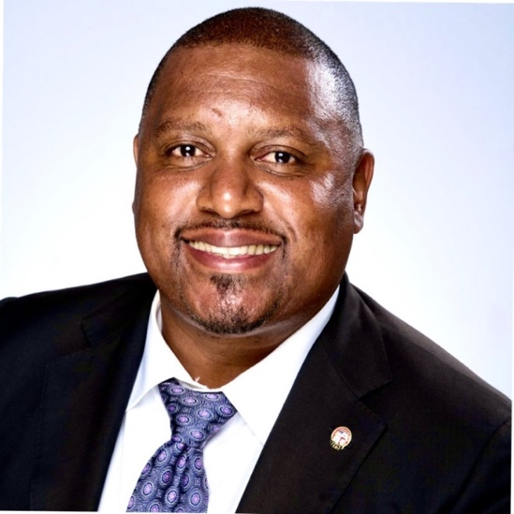
Sheldon Cruz
Director of Strategic Partnerships & Government Affairs, Department of Youth Development
City of Los Angeles, CA
Sheldon Cruz is native born Angelino, he currently serves as the Director of Strategic Partnerships & Government Affairs for the newly established City of Los Angeles Youth Development Department. He has over 20 years of experience as a civil servant, he previously served as the Director of Youth Engagement for the LA Civil Rights + Equity Department, where he developed the department's youth engagement methodology to assure equitable access to city services, programs and employment opportunities for youth. Prior to his joining the LA Civil Rights Department, he served as the liaison to the City’s Affordable Housing Commission where he provided direct input on strategic planning, marketing and branding strategies. Sheldon has provided comprehensive programming in some of the most underrepresented and underserved communities in Los Angeles including Watts, South LA, Baldwin Village, Venice and Boyle Heights. Mr. Cruz is very passionate about youth and community engagement and strives to assure that youth and Angelinos are empowered and engaged in the civic process at the local, state and federal government levels. In fact, Mr. Cruz received a Presidential Greeting from President Barack Obama in 2016 for establishing a civic engagement and experiential learning curriculum that provided youth populations with opportunities to learn about the civic process, advocate for policy and create community based service projects within their respective communities.
Rebekah Dixon
Youth Employment Program Manager
City of Raleigh, NC
Rebekah Dixon, a native of Greenville, NC, has been an educational and youth development program specialist in Raleigh for over 18 years. She believes the best way to improve the community is to create opportunities to enhance learning opportunities, lived experiences and increased resources for the youth of Raleigh. Rebekah holds a Bachelor of Science in Program Management from North Carolina State University, a Master in Education with a concentration in Secondary Education from Grand Canyon University, and a current doctoral student in Educational Leadership K-12 at Grand Canyon University. She currently oversees and manages the Raleigh Summer Youth Employment Program with the City of Raleigh. Rebekah also serves as a part time advisor to the GED program at Wake Technical Community College in Raleigh, NC. Rebekah loves attending live concerts, attending sporting events and cheering on her favorite sports teams, and sitting by the ocean.
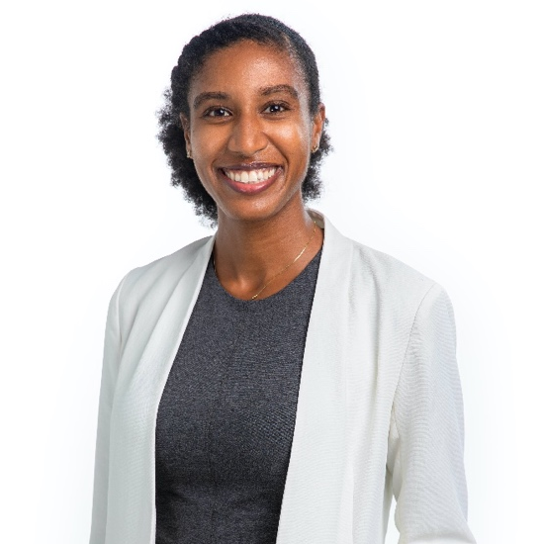
Briana Evans
Equity & Inclusion Officer
City of Redwood City, CA
Briana Evans has focused her career on building communities in which every member can thrive. Briana currently serves as Redwood City’s first Equity and Inclusion Officer where she supports departments to ensure equitable services for the whole community and genuine workforce belonging for employees. Previously, Briana has worked as an equity design strategist with Reflex Design Collective, a consulting firm that uses collaboration to co-design solutions that advance social equity. She has also served as a Senior Community Health Planner in San Mateo County Health’s Office of Diversity and Equity where her team co-designed culturally responsive behavioral health services with clients and families that reflected the diversity of the jurisdiction. In another part of her professional life, Briana is a facilitator for Stanford Business School’s Women in Management and Interpersonal Dynamics programs, which support individuals to build interpersonal connections and make mindful choices about their impact as leaders. Briana completed Bachelor’s and Master’s studies in Anthropology at Stanford University.
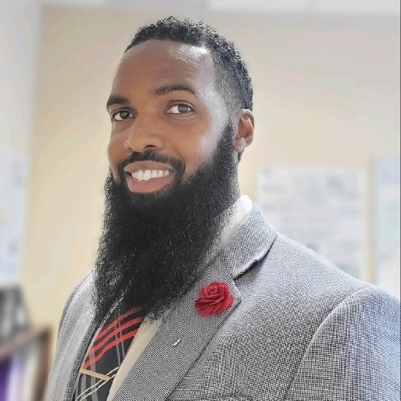
John Everett
Director of Workforce Development, Kids Hope Alliance
Jacksonville, FL
John is an experienced professional with over 20 years of experience empowering young people. He excels in cross-sector collaboration, social futurism, and change management. As a Community Partnership School Director, he honed his skills in bringing together private and public support for community initiatives, specifically around preparing youth for life after high school. In his current role, John leads the city's workforce development efforts which include sustaining a true high school to high wage system. His expertise in change management has been instrumental in establishing the city's first workforce development department and leading several initiatives, including the Mayor's Youth at Work program (MYAWP), Mayor's Young Leader's Advisory Council, Cities for Financial Empowerment initiative, National League of Cities (Addressing Basic Needs of Postsecondary Students) initiative, and MYAWP steering committee. John's educational background includes a Masters in Mental Health Counseling, BS in Psychology, and BS in Sociology, which informs his deep understanding of human behavior and social systems.
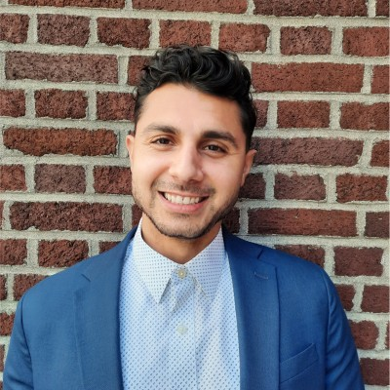
Ren Floyd-Rodriguez
Young Adult Workforce Programs Manager, Office of Economic and Workforce Development
City of San Francisco, CA
Ren Floyd-Rodriguez serves as the Young Adult Workforce Programs Manager in the Office of Economic and Workforce Development for the City and County of San Francisco. As a passionate administrator, he is motivated to create opportunities for young people to work, innovate, and prosper in their communities. Ren oversees a wide variety of young adult workforce programming to connect youth to careers including job centers, subsidized employment, and paid work experience. He also works to affect change through economic recovery and racial equity investments such as the Dream Keeper Initiative to reinvest in San Francisco’s diverse Black communities, Equity Pilot programs to support immigrants, and cash transfer programs aligned with Guaranteed Income models embedded in earn-and-learn vocational training. Ren previously managed local workforce development programming for community-based organizations in San Francisco’s Mission District and in Los Angeles with YouthBuild. He received his Bachelor of Science in Economics and his Master of Public Administration focusing on public sector leadership and management.
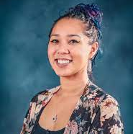
Victoria Grace-Barksdale
Youth Coordinator
City of Vallejo, CA
Victoria Grace-Barksdale the Youth Coordinator for the City of Vallejo and a Vallejo native, born and raised. She is an avid youth and community advocate and has spent many years developing youth programming and connecting youth and families to the resources they need. She attended K-12 schools in Vallejo, moving on to earn her BA in Sociology with a minor in Education and Applied Psychology from the University of California, Santa Barbara. Before joining the City of Vallejo, Victoria worked as an Academic Support Provider for the Vallejo City Unified School District where she case-managed students in need of extra support or services. She also advised leadership teams, ran restorative justice activities, coached social emotional learning groups and sports teams, organized empowerment groups, and created community collaborative teams to support the school sites she worked at. Victoria continues to serve the Vallejo community as an event coordinator and youth advocate through her volunteer work with non-profits. She has served on numerous boards aimed at improving the lives of youth and underserved populations in her community. Victoria currently serves on the board of directors for Vallejo Together and the Vallejo Sister City Association focusing on unhoused youth and international diplomacy. Victoria continues to be an active community member with a true passion for improving opportunities for youth, which she brings to her role in the City of Vallejo. As the City’s first-ever Youth Coordinator, Victoria is continuing to identify needs and resources, establish youth engagement opportunities, increase youth voices in local government and build partnerships and pathways towards brighter outcomes for Vallejo youth.
Shannon Harris
Our Community’s Children Executive Director
City of Grand Rapids, MI
Shannon L. Harris is the Executive Director of Our Community’s Children, a public/private partnership between the City of Grand Rapids, Grand Rapids Public Schools and community partners. She has nearly 30 years of experience in youth development and was hired by the city manager of Grand Rapids in 2021 to assume this role. Shannon has designed an award-winning youth employment program and oversees programs and initiatives in the areas of afterschool system building, civic engagement, post-secondary success and youth employment. Shannon serves on the Michigan Afterschool Partnership’s leadership team, is a member of the National League of Cities’ Mayor’s Education Policy Advisors Network and she is a KConnect Lead Convener Partner. She has a Bachelor of Science in Journalism from Florida A&M University. Shannon is an accomplished dancer and choreographer and has created dance productions for high school dance troupes and international trade shows. She is an author, documentary film buff and loves to travel. Shannon is also a proud member of Delta Sigma Theta Sorority, Incorporated.
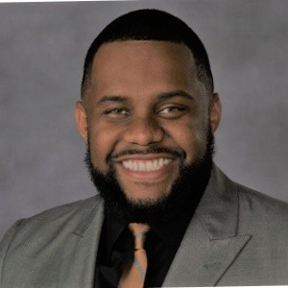
Dr. Lerone Joseph
Program and Operations Manager, Office of Community Wealth Building
City of Richmond, VA
Originally from New York City by way of the Caribbean, Dr. Lerone Joseph is a Youth Advocate and Scholar-Practitioner with over ten years of progressive experience in young adult development and higher education. His background includes teaching, community engagement, and career services. Dr. Joseph has worked on many initiatives that support Black male education, professional development, and community action for underrepresented youth. Dr. Joseph is the Program and Operations Manager for the Mayor's Youth Academy (MYA) with the City of Richmond's Office of Community Wealth Building. MYA's mission is to develop Richmond's future workforce, ages 14-24, by improving access to employment, professional and leadership development. Dr. Joseph and his team oversee summer work and internship opportunities for over 500 youth. Dr. Joseph received his Bachelor's Degree from the University of Albany (SUNY) and his Master of Justice Administration and Public Policy from the University of New Haven. In addition, he holds several certifications that support his work in developing youth, including Meyers-Briggs Type Indicator (MBTI), Restorative Justice, Work Place Excellence, and Youth Mental First Aid. Dr. Joseph's commitment to education was recognized in 2013 by Winston Salem State University and in 2017 by Auburn University's President with the Excellence Awards. In 2021, he completed his doctoral studies in Higher Education Leadership, with his research focused on the leadership development and advancement of African American males in predominately white institutions. Dr. Joseph is no stranger to hard work and credits his passion for youth to his lived experiences and the professional opportunities he has been afforded. He is excited and honored to be part of the National League of Cities' inaugural cohort of the Youth Excel Fellows Initiative. Dr. Joseph views this opportunity as a transformative way to continue the work of supporting youth from economically disenfranchised communities in the City of Richmond.
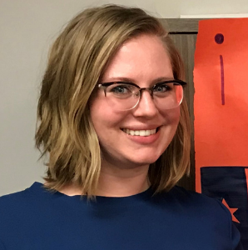
Marlys McKinney
Senior Management Analyst – Children and Youth Success
City of San Antonio, TX
Marlys McKinney is a first-generation college graduate from Southwestern University, where she studied Economics and Political Science. Since then, she has prioritized having diverse experiences that have ultimately informed her passion for equity. After participating in the JET program, teaching English in Japan, she participated in AmeriCorps in San Antonio, Texas working with asylum-seekers. She later moved to New Zealand where she worked for the Ministry of Education on the School Governance team, then returned to work with first-generation college students at the University of Texas at San Antonio. She is now a Senior Management Analyst on the Children and Youth Success Team of the Department of Human Services for the City of the San Antonio.
Emily Norris
Youth Engagement Coordinator, Office of Community Empowerment
City of Knoxville, TN
Emily has worked with the City of Knoxville’s youth-focused initiative, Empower Knox, since November 2020 and was hired as the Youth Engagement Coordinator for the City of Knoxville in July 2022. Within the Empower Knox initiative, she manages the Mayor’s Youth Council, Summer in the City internship program, Community Empowerment Academic Fellowship, and Mayor’s Community Empowerment Roundtable of Youth-Serving Organizations. She collaborates with community partners on the Roundtable and has launched several projects including Empower Knox Community Partnerships, a program for grassroots nonprofits to build capacity and social capital, and the Mayor’s Social Innovation Challenge, a pitch competition centered on youth mental health. With the Mayor’s Youth Council, she planned and hosted the city’s first Youth Summit on November 19, 2022, where over 60 area youth gathered and discussed challenges and creative solutions to address homelessness, mental health, violence prevention, and civic engagement in Knoxville. What she loves most about her role is creating opportunities for youth to engage in local government and their communities and find common ground among diverse backgrounds and perspectives. Emily began her first career in 2006 as a ballroom dance competitor, instructor, and studio owner and is a four-time Dancing with the Knoxville Stars Champion. Over 10 years, she helped to raise over $1 million for East Tennessee Children’s Hospital through the DWTKS event, but in 2018, that ground to a halt when she was diagnosed with several medical conditions that were incompatible with a continued career in dance. She went on to write for Knoxville Style Magazine and earn a Bachelor’s Degree in Social Work and Top Collegiate Scholar award from the University of Tennessee College of Social Work, where she is currently a Master’s Candidate. She also serves on the Chancellor’s Commission for Disability at UT and advocates for individuals with disabilities to have prospects not only in jobs and employment, but opportunities to use their unique talents to support thriving careers in sectors they are passionate about.
Karissa Selvester
Executive Director, Mayor’s Fund for Education
City of Long Beach, CA
Karissa Selvester is the Executive Director of the Mayor’s Fund for Education within the City of Long Beach. She leads the Fund’s community engagement and development efforts in support of each of its three focus areas – Early Childhood Education, Internship Opportunities, and Improving College Completion. The Mayor’s Fund for Education seeks to join private, public, philanthropic, and civic resources to address the most pressing education issues facing the students of Long Beach. Karissa’s efforts work to strengthen the City’s existing notable educational programs, improve alignment between complimentary programs, and facilitate the establishment of new programs aimed at ensuring all students have access to educational and careers pathways resulting in a thriving local economy. Karissa brings to the Fund a diverse professional background in public affairs, urban planning, government relations, grant writing, and public-private partnerships. Throughout her career, Karissa has been successful in building mutually beneficial and collaborative relationships with public officials and community partners. Karissa serves on the Board of the Long Beach Early Childhood Education Committee, Board of Long Beach Career Linked Learning (CALL), Educare Advisory Committee, Long Beach All Children Thrive Steering Committee, and Co-Chairs the Long Beach Early Childhood Education Strategic Plan Oversight and Implementation Committee.
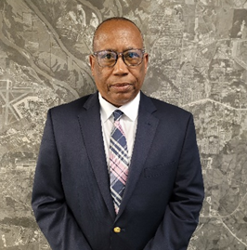
Desmond Wilson
Director of Community Development
City of Montgomery, AL
City of Montgomery Tenure
- 21 years at the City of Montgomery
Current Position at City
- Director of Community Development- Responsible for the following divisions- Development, Community Development and Land Use Control
Previous Positions at City of Montgomery
- Grants Administrator- Community Development Division- Responsible for the U.S. Department of Housing and Urban Development (HUD) Entitlement Funds-
- Community Development Block Grant (CDBG) Funds,
- Home Partnership Investment Programs (HOME),
- Emergency Solutions Grant Program (ESG)
Grants Coordinator- Community Development Division
Program Manager for the HOME and ESG programs
Other Relevant Experiences
- Grants Specialist for Institutional Planning & Advancement Department- Alabama State University
- Procurement Technical Assistant Center Program Manager (Government Contracting-Department of Defense and Small Business Administration Programs) at the College of Business Administration Alabama State University
- Small Business Counselor (Small Business Administration-Small Business Administration at the College of Business Administration Alabama State University
- Defense Contract and Project Manager and Proposal Preparer for 8(a) Small Business- Air Force, Army, Navy, Corp of Engineers
Education:
- Justice and Public Safety (Police & Security Management) - Auburn University at Montgomery
- Business Administration (Finance and Marketing) - Faulkner University Montgomery
Current NLC Projects Involvement
- Southern Cities Economic Inclusion
- Fines and Fees Forgiveness
- Cities of Opportunities
- City Inclusive Entrepreneurship Network

