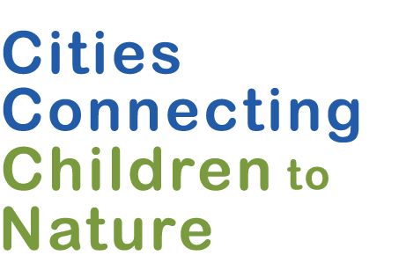

Systems Change Outcomes Tracking Tool

The Systems Change Outcomes Tracking Tool provides questions to prompt discussion and reflection on how your city has advanced systems changes that can lead to important outcomes for children and youth, particularly those traditionally underrepresented.

The tool is most useful when it aligns with the end of a significant project, an annual review process, or the preparation of a report, funding application, or communication where progress can be shared. Systems change work is iterative. You may not have examples in each category. If your team uses this tool to inform next steps, consider also using the Internal Assessment Tool to identify specific practices to implement.

Date Completed: ________________ Time Period Covered: _____________ to _____________
POLICY: New and revised policies and regulations that support equitable access to nature.
What specific citywide, city agency, or organizational policies or regulations have been introduced, initiated, or enacted that increase opportunity and/or access to nature for children and youth who have historically been excluded? What has resulted?

- Citywide policies/regulations:

- Agency policies/regulations:

- Organizational policies/regulations:

PRACTICES: New practices and expanded programs that support equitable access to nature.
What opportunities or programs have been developed or changed to draw children and families to nature more equitably in our city?

RELATIONSHIPS & CONNECTIONS: Enhanced connections among partners.
- Which key partners have we engaged in advancing nature connections for more children and youth?
- How have we engaged partners with a focus on equity or who are embedded in communities of color?
- How have partners contributed to advancing the goal of increasing opportunity and/or access to nature for children and youth of color?

RESOURCE FLOWS: Reallocated and new resources to support equitable access to nature.
What resources (funding, staff, infrastructure, knowledge) has our city been able to leverage to increase children’s equitable access to nature?

Staffing, infrastructure, knowledge:
- City resources:

- Federal/state resources:

- Other resources:

Financial: (Estimates are acceptable)
- City: $_____________________

- Federal/state: $_____________________

- Private/Foundation Resources: $_____________________

POWER DYNAMICS: Meaningful engagement of and leadership by city leaders, youth, and community members.
- How has city leadership (mayor, agency heads, other elected officials or leaders) been engaged in supporting opportunities for children and youth to connect to nature?
- To what extent have we engaged youth and families of color in the design and implementation of our city’s efforts to connect children to nature?
- What has changed as a result of engagement of city leadership, youth, families, and organizations led by people of color?

ATTITUDES & BELIEFS: Expanded commitment to children’s equitable access to nature and changes in preconceived notions and long-held assumptions.
- In what ways is the city helping to foster changes in attitudes and beliefs relative to children’s equitable access to nature?
- In what ways have efforts shifted attitudes and beliefs about who has a place in nature?

Informed by the following guides and tools: FSG, Guide to Evaluating Collective Impact, 3: Sample Questions, Outcomes, and Indicators, ND. CCCN. CCCN Implementation Competencies Framework, March 2019. CCCN. CCCN Project Sustainability Framework, May 2017. Build Health Challenge, Community Approaches to Systems Change: A Compendium of Practices, Reflections, and Findings, November 2019.

